**Results of Freshwater Surveys show Biological Improvements**

To assess the impacts of their project on water quality, Upstream Thinking commissioned surveys to examine the invertebrate communities present in rivers and streams within their working catchments. The surveys were carried out in the autumn of 2019 and spring of this year; the results have just been released and they’re really positive!

Invertebrates are good indicators of water quality; the presence or absence of certain species points to enrichment of water with nutrients, which can arise from agriculture amongst other sources. Dr Bruce Forrest of Forrest Ecological, used the River Invertebrate Classification Tool (RICT) system to produce a simple score for biological status for each monitoring site. A second system, the Species at Risk (SPEAR) index, was used to specifically assess the presence of pesticides. Both indices are based upon the species of invertebrates found using a ‘kick sampling’ technique in flowing water.

These surveys were first carried out early in the Project, in 2016, so we were able to look for any changes in scores since then. The results are very positive, with many of the sample sites demonstrating an improvement in the RICT and SPEAR scores over time, and more watercourses exhibiting ‘High’ biological status.

Meanwhile, the few sample points highlighted as having ‘Poor’ or ‘Moderate’ biological quality, reflect what we know about the analytical chemistry of those sites, based upon our routine monitoring programmes. This gives us a steer on where to focus our efforts in the future.

The fact that the biological quality of these waterbodies is improving, with most reaching ‘High’ or ‘Good’ status, is a great testament to land management within the catchments. Better agricultural practice leads to less pollution reaching watercourses and this is a win for water quality and wildlife.

For more information on the work Upstream Thinking are doing in the Catchments of the Falmouth Reservoirs, the River Cober, Drift Reservoir and since 2020, Stithians Lake, please see our website and that of South West Water who fund us. Links.



Streams in the catchment of Argal Lake have seen improvement in classification against the SPEAR index, indicating less influence of pesticides. In 2016, our monitoring sites were measured as being of either ‘Poor’ or ‘Moderate’ condition, in contrast, our recent surveys have shown sites as being either ‘Moderate’, ‘Good’ or ‘High’ SPEAR status.



All sites monitored in the Drift Reservoir Catchment are now classified as having ‘High’ biological status according to RICT, demonstrating healthy diversity and abundance of invertebrate life.





Our monitoring of streams feeding into the upper reaches of the River Cober demonstrates a change in invertebrate species present, to include species with a lower tolerance of pesticides. More of the sites surveyed are now classed as having a ‘High’ biological status.

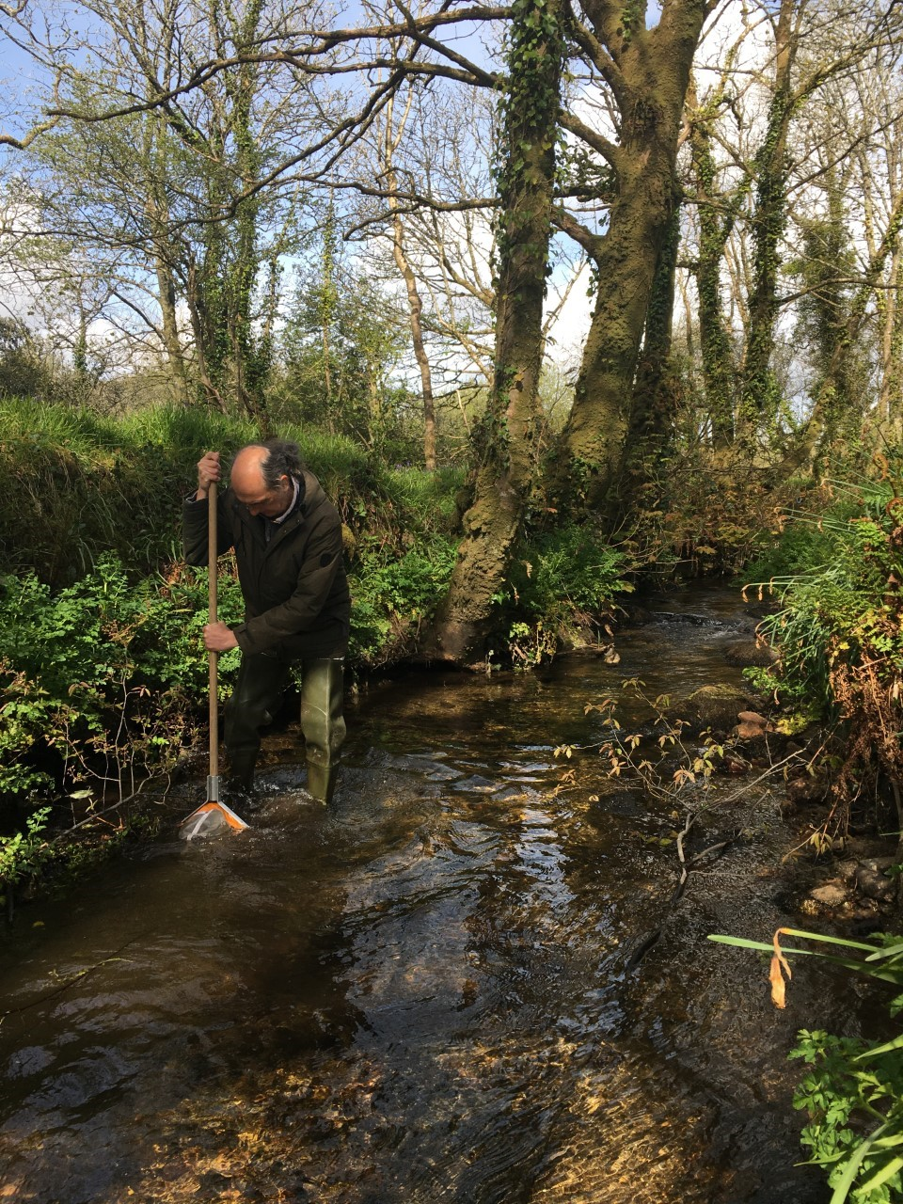

Dr Bruce Forrest Kick Sampling in the River Cober Catchment

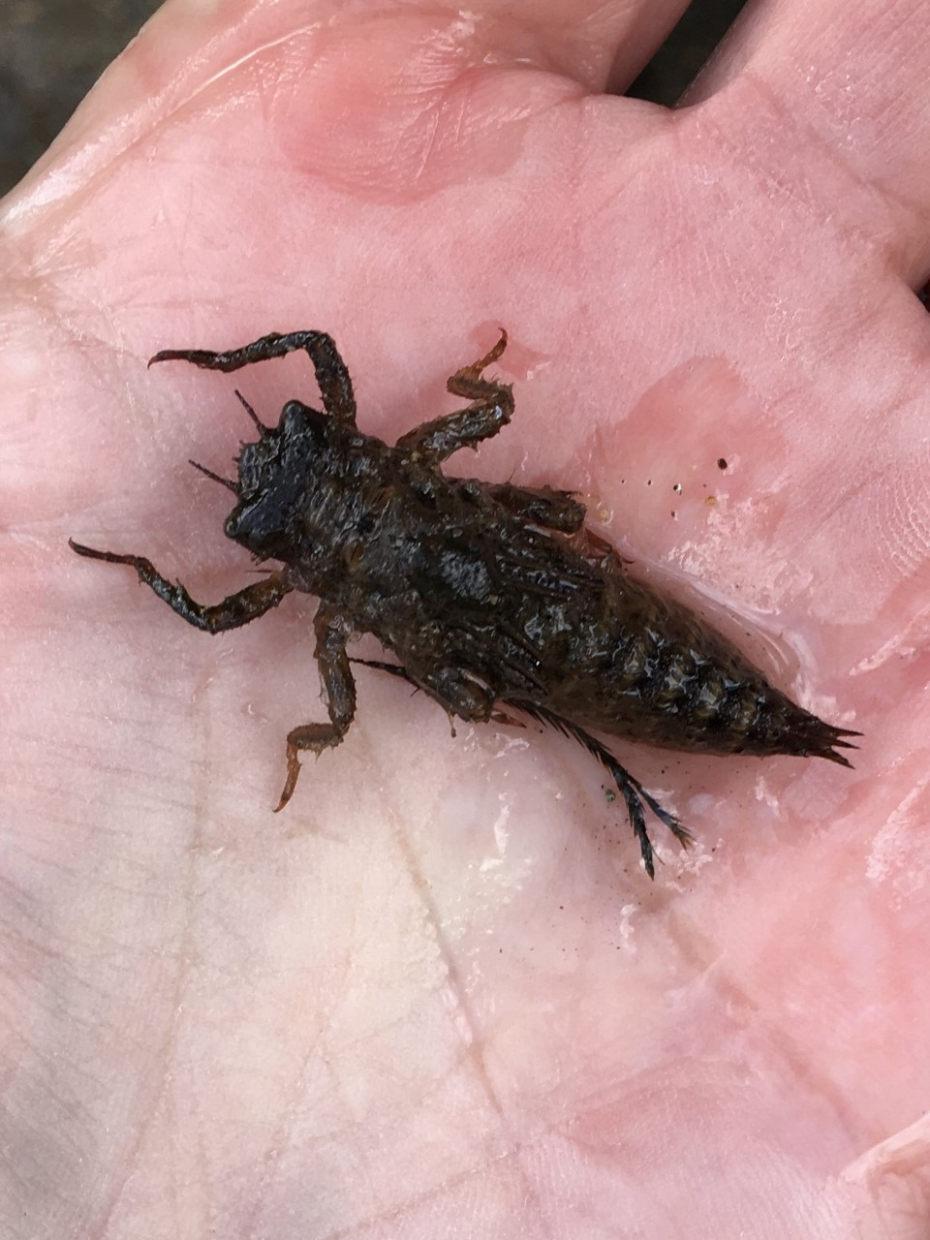

Many Dragonfly Nymphs were Identified (Cordulegaster boltonii)