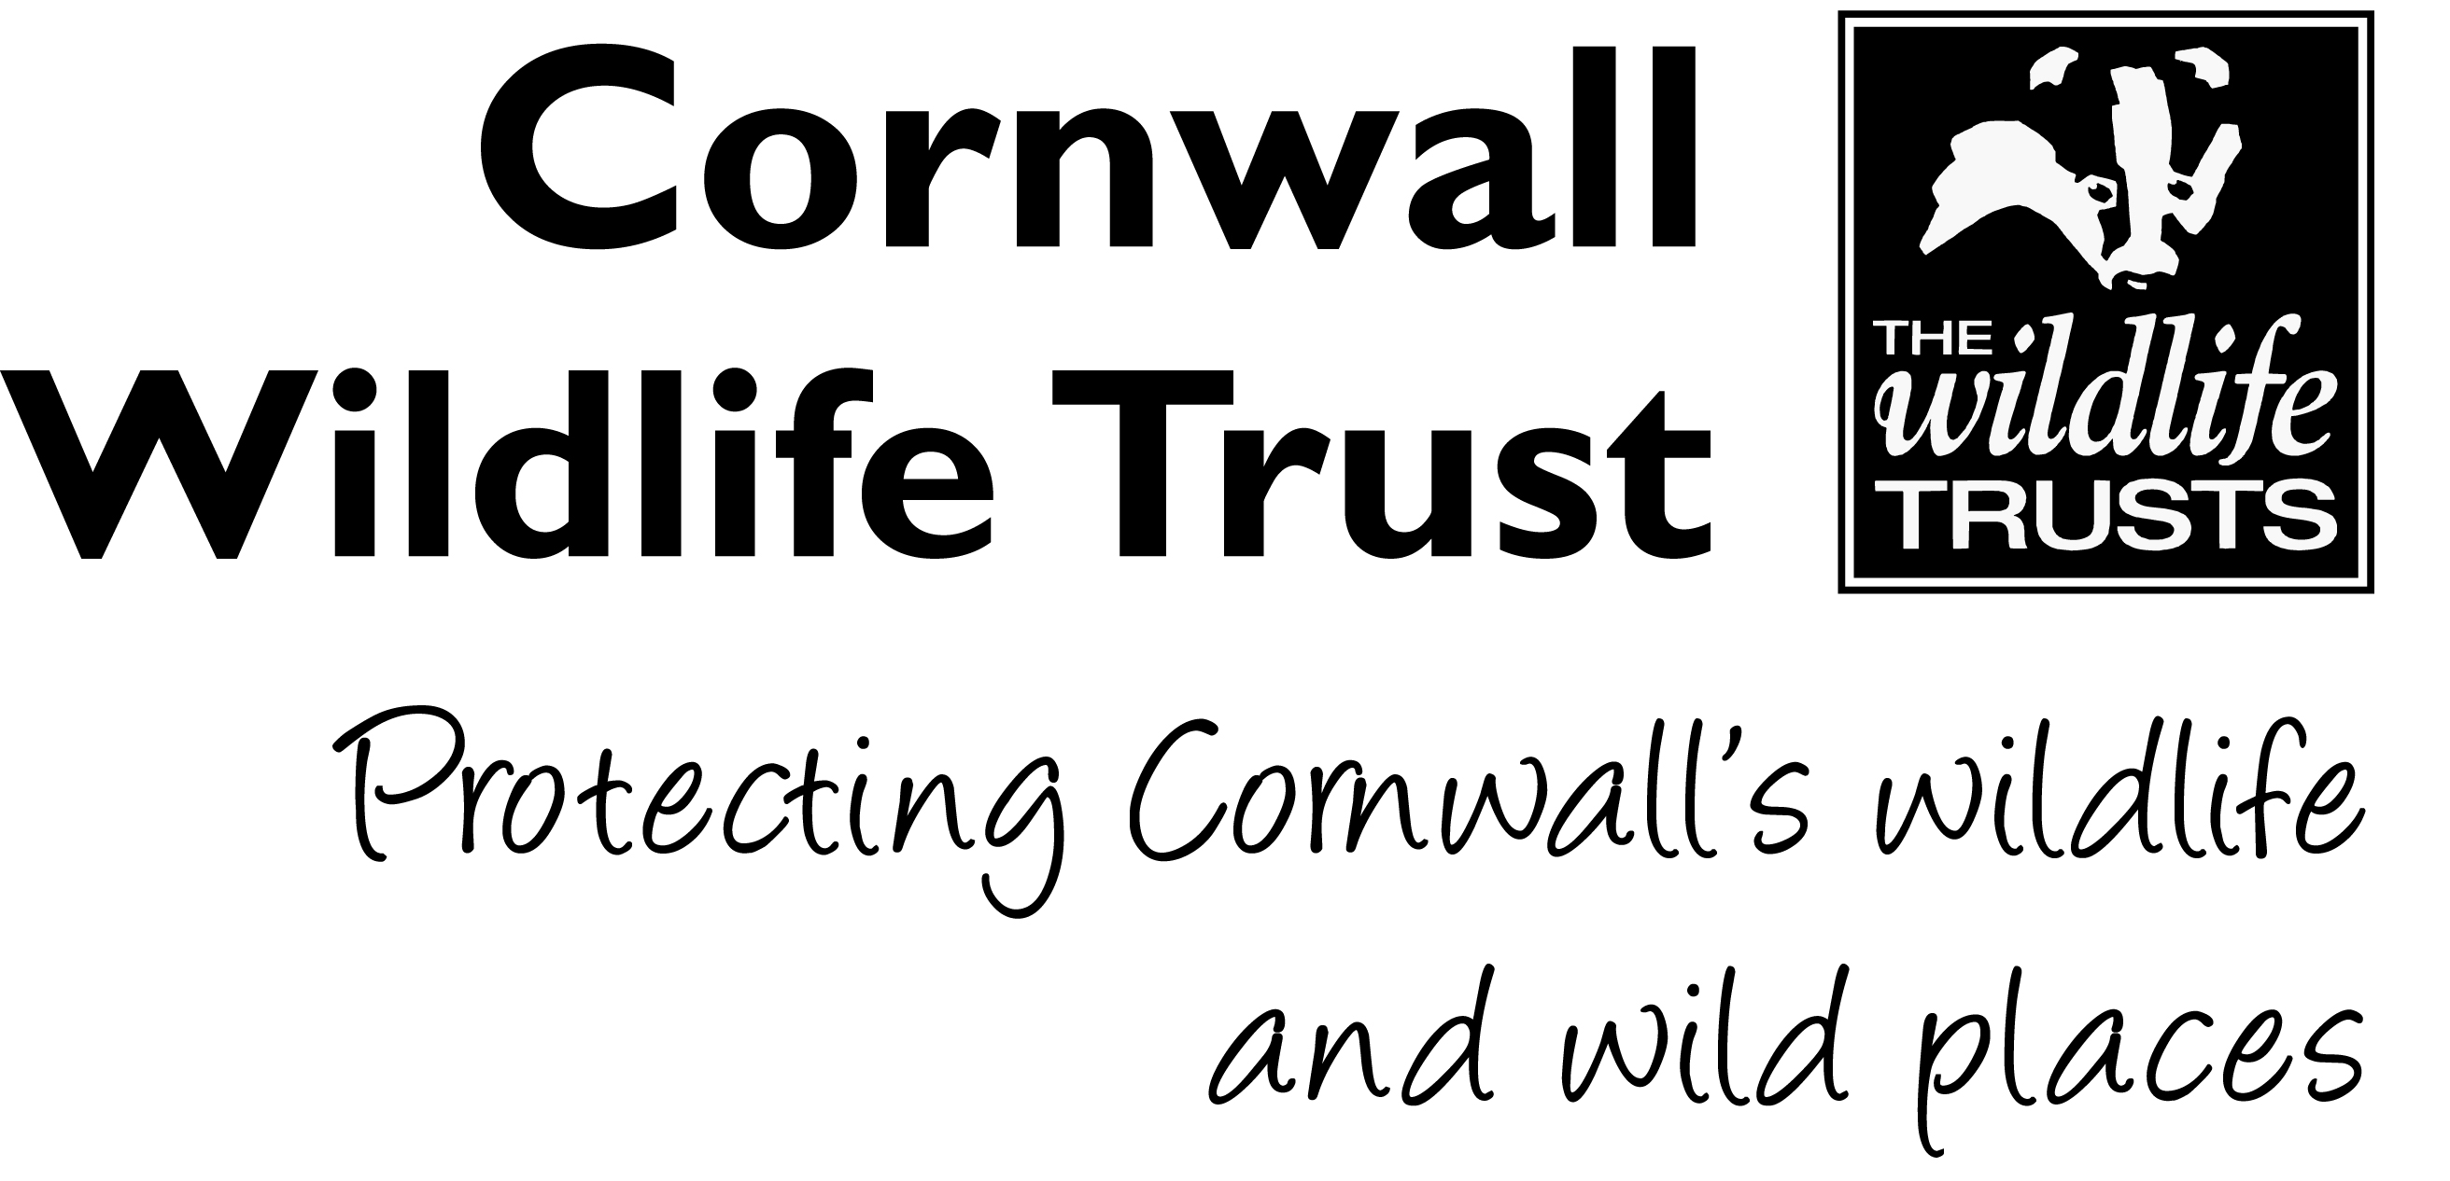

JOB DESCRIPTION

-------------------------------------------------------------------------------------------------------------------------------
- IDENTIFICATION OF JOB
-------------------------------------------------------------------------------------------------------------------------------

JOB TITLE : Area Reserves Manager - Mid Cornwall

POST NUMBER : 69b

FUNCTION : Reserves

RESPONSIBLE TO : Head of Nature Reserves

RESPONSIBLE FOR : Mid Cornwall Reserves Officer, Penhale Dunes Ranger, Project Officers on specific projects, volunteers and contractors as required

-------------------------------------------------------------------------------------------------------------------------------
- OVERALL PURPOSE OF JOB
-------------------------------------------------------------------------------------------------------------------------------

Project management of all operations on nature reserves in the Mid Cornwall Area (see attached list). This involves setting programmes of work and advising the Head of Nature Reserves of the budget requirements for the annual work plans. The Mid Cornwall Reserves Manager is responsible for ensuring that the work plans are implemented through managing the Mid Cornwall Reserves Officer, Penhale Dunes Ranger, Project Officers as appropriate and the supervision of contractors and volunteers.

-------------------------------------------------------------------------------------------------------------------------------
- MAIN RESPONSIBILITIES
-------------------------------------------------------------------------------------------------------------------------------

Reserve Management:

- Set work plans for the Mid Cornwall Nature Reserves in response to the following drivers:

- Habitat management and restoration,
- Agri-environment schemes,
- Cross compliance with Basic Payment Scheme,
- Maintaining the health and safety of staff, volunteers and public,
- Management plans,
- Other grant funding,
- Estate infrastructure,
- Public access,
- Visitor experience,
- Biological monitoring.

- Oversee delivery of these work plans by:

- Carrying out the work in person,
- Line management of the Reserves Officers, Penhale Dunes Ranger and Project Officers, who’s key roles are to deliver these work plans,
- Supervising contractors,
- Co-ordinating volunteer labour, and
- Co-ordinating staff colleagues in the Reserves team

- Ensure appropriate systems are in place to project manage this work utilising IT resources to facilitate reporting and tracking by other staff.

- Maintain an up to date understanding of developments in policy and theory in relation to Reserves management. Lead on the future direction of nature reserve management in Mid Cornwall in liaison with Trustees, Trust staff and other countryside management professionals.

- Project manage practical contracts including; preparing specification and tender documents, selecting contractors and supervising them on site.

Budgets, Financial Management and Funding:

- Prepare annual budgets for the delivery of the annual work plan, and provide them to the Head of Reserves for approval.

- Manage and monitor the Mid Cornwall budget and project expenditure with a degree of autonomy to ensure it is at or below the agreed annual budget at the end of the financial year. Prepare order numbers and ensure contractors invoice according to agreed rates, within the agreed timescales.

- Apply for agri-environment schemes to fund work on nature reserves. Prepare quotes, reports and data to support these applications,

- Carry out monitoring and recording in accordance with the agri-environment and Basic Payment Scheme (BPS) requirements,

- Submit claims to the Rural Payments Agency in accordance with the agri-environment scheme requirements,

- Apply for funding from other sources as required and deliver, administer and report against the terms of funding.

Reporting, compliance and Planning:

- Ensure compliance with agri-environment and BPS requirements, protecting the Trust from the risk of fines.

- Commission consultants to prepare reports and management plans as required to provide an evidence base for reserve management decisions.

- Report to the Head of Reserves, Senior Management Team and Trustees on progress against the Trust’s Business Plan and prepare specific reports where issues relating to the Mid Cornwall Reserves arise.

- Ensure that all operational activities on reserves are compliant with appropriate licensing requirements. Apply for the appropriate licences as necessary to include felling licenses, SSSI Consent, EIA, land drainage approval, planning permission and Environment Agency consent for operations around water.

- Develop the Trust’s management planning system for nature reserves in Mid Cornwall. Ensure adequate reporting and monitoring of work is carried out to assess progress against targets.

Health and Safety – protect the Trust from the risk of non-compliance on health and safety matters:

- Ensure on-site health and safety monitoring is carried out according to the departmental systems.

- Ensure any tasks identified through this monitoring are added to the work plans and delivered, seeking additional budget as required.

- Manage the grazing system to ensure that grazing is adequately risk assessed and safety signage is in place.

- Ensure health and safety legislation is adhered to by ensuring that systems of work are in place and delivered by Reserves staff and volunteers.

Engagement:

- be the face of CWT on reserves matters in Mid Cornwall:

- Organise and carry out community consultation exercises,
- Carry out media interviews,
- Prepare articles for Wild Cornwall and other publications.
- Monitor website content for Mid Cornwall nature reserves ensuring it is factually correct and up-to-date.
- Organise and deliver events for members and the public.
- Attend and influence community meetings including Parish Councils as necessary.
- Liaise with the Trust’s Local Groups and their representatives in the Mid Cornwall area where necessary.

- Recruit and support a network of Voluntary Wardens for the Mid Cornwall nature reserves.

General:

- Liaise with legal professionals and the Trust Land Agent on matters requiring professional advice.

- Monitor and enforce the integrity of the Trust estate, responding to land encroachment and boundary disputes as required,

- Liaise with the Head of Reserves in the assessment of potential new Nature Reserves.

- Develop partnerships with key stakeholders in Mid Cornwall to more effectively deliver shared goals, participating in joint funding bids if opportunities arise. Negotiate working relationships, financial arrangements, work in kind and shared resources as appropriate.

- Prepare annual grazing agreements with a range of farmers and livestock owners, agreeing fees, timings, transport, numbers and locations. Ensure that graziers complete the required regulatory paperwork.

- Build relationships with the farms adjoining nature reserves to facilitate more effective Reserve management, including new opportunities to provide grazing of Reserves.

- Attend Reserves Team Meetings, Reserves Advisory Group meetings, Trustee meetings, external stakeholder meetings and staff meetings. Influence external meetings as appropriate.

- Ensure the Reserves operations are adequately resourced with well-maintained tools and facilities.

- In order for the organisation to work effectively, assist with other areas of work and be prepared to undertake other duties appropriate to the post, as delegated by your line manager. Liaise with members of staff in other departments of the Trust to share knowledge and skills and support the wider work of the Trust.

- All staff are required to abide by organisational policies and procedures.

Please sign and date this document to confirm its accuracy at the present time.

Job Holder: ………………………………………………………… Date: …………………....

Line Manager: …………………………………………………….. Date: …………………….

MID CORNWALL AREA RESERVES

- Allet Bog
- Carn Moor
- Chyverton
- Downhill Meadow
- Fal-Ruan Estuary
- Five Acres
- Fox Corner
- Halbullock Moor
- Hawkes Wood
- Helman Tor (including Breney, Red Moor, Lowertown, Crift, Helman Tor, Higher Trevilmick, Lower Penhale)
- Lanvean Bottoms
- Nansmellyn Marsh
- Park Hoskyn
- Penhale Dunes
- Prideaux Woods
- Quoit Heathland
- Redlake Cottage Meadows
- Ropehaven Cliffs
- Rosenannon Downs
- Tresayes Quarry
- Tregonetha Downs
- Ventongimps Moor

PERSON SPECIFICATION

JOB TITLE : Mid Cornwall Reserves Manager

POST NUMBER : 42

FUNCTION : Reserves

This section details the experience, skills, knowledge and personal qualities required for the post.
Area A EXPERIENCE | ESSENTIAL | DESIRABLE
- Partnership working | ✓
- Budgets and financial management | ✓
- Grant scheme administration |  | ✓
- Project management | ✓
- Line management of staff |  | ✓
- Delivery of habitat management and restoration work | ✓
- Engaging and supervising contractors |  | ✓
- Grazing scheme management | ✓
Area B KNOWLEDGE
- Relevant degree or equivalent qualification |  | ✓
- Health & Safety legislation | ✓
- Current knowledge and specialism in habitat management | ✓
- Land management regulatory framework |  | ✓
- Land management schemes |  | ✓
Area C SKILLS
- Habitat and species monitoring and recording | ✓
- IT skills: GIS, Spreadsheets, report writing, media based presentations | ✓
- Tractor driving and implement operation |  | ✓
- Livestock management | ✓
- Chainsaw – medium trees and above | ✓
- Trailer driving | ✓
- Estate infrastructure installation and maintenance | ✓
- Use of herbicides |  | ✓
- Media and community engagement | ✓
- First aid |  | ✓
Area D PERSONAL QUALITIES
- Enthusiasm, self-motivation and initiative | ✓
- Good verbal communicator and negotiator | ✓
- Ability to manage own workload and prioritise | ✓
- Commitment to wildlife conservation | ✓
- Ability to make decisions based on evidence and knowledge | ✓
- Negotiation skills | ✓

