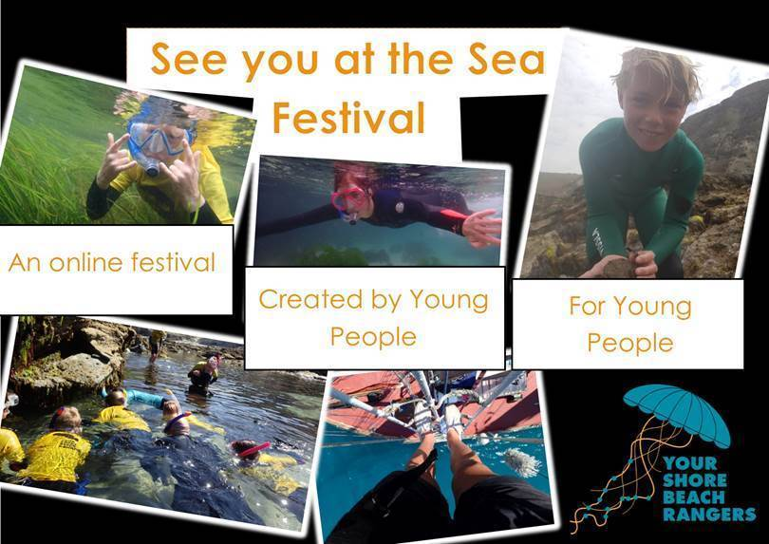

This year, See you at the Sea Festival will be an online film festival, for young people, created by young people. The idea is that young people create short films promoting their blue voice - that means anything to do with you and the sea – “Perhaps you’re an artist who engages with the ocean through pictures or paintings and you want to share what you do with other young people. Maybe you are concerned about an issue facing the ocean such as the increased use of facemasks and want to raise awareness. Whatever way you engage with the sea, if you can make a film about it, you could be part of See you at the Sea Festival 2020”.

All young people must be aged 11-24 years old and live in Cornwall.

Don’t have fancy equipment? Don’t worry! You can make your films on your phone and there is free online editing software out there.

All participants must complete the application/brief and tell us about what you hope to create (Attached)

**Closing date for films – Monday 16th November 2020**

Videos must be at least 10 minutes in length, but no longer than 40 minutes.

Selection process –

•         Please fill out this short application and tell us your vision.

•         Once you have applied, we will select the videos we would like to be made.

•         If your video is selected to be made, the individual or team will receive £150 for your time on us receiving the finished film.

•         Not all videos made will be played on the day, we will select ONLY 8 (but you will still receive the £150 for your time).

•         The 8 videos chosen to be played as part of the festival will be entered into the prize draw.

•         There will be prizes for the top three videos on the day (judged by number of views, number of shares, and judges scores on the day) - first, second and third place.

•         It will be up to you to promote your film to get as many views as you can.

•         1st place will receive vouchers equating to the value of £300, 2nd place £150 and 3rd place £50.

•         Vouchers will be for wildlife or employment based websites such as <https://www.nhbs.com/gifts>, <https://www.cornwallwildlifetrust.org.uk/shop>, <https://www.field-studies-council.org/> . Other options may be considered and can be discussed, please speak to Jenn Sandiford on [jennifer.sandiford@cornwallwildlifetrust.org.uk](mailto:jennifer.sandiford@cornwallwildlifetrust.org.uk)