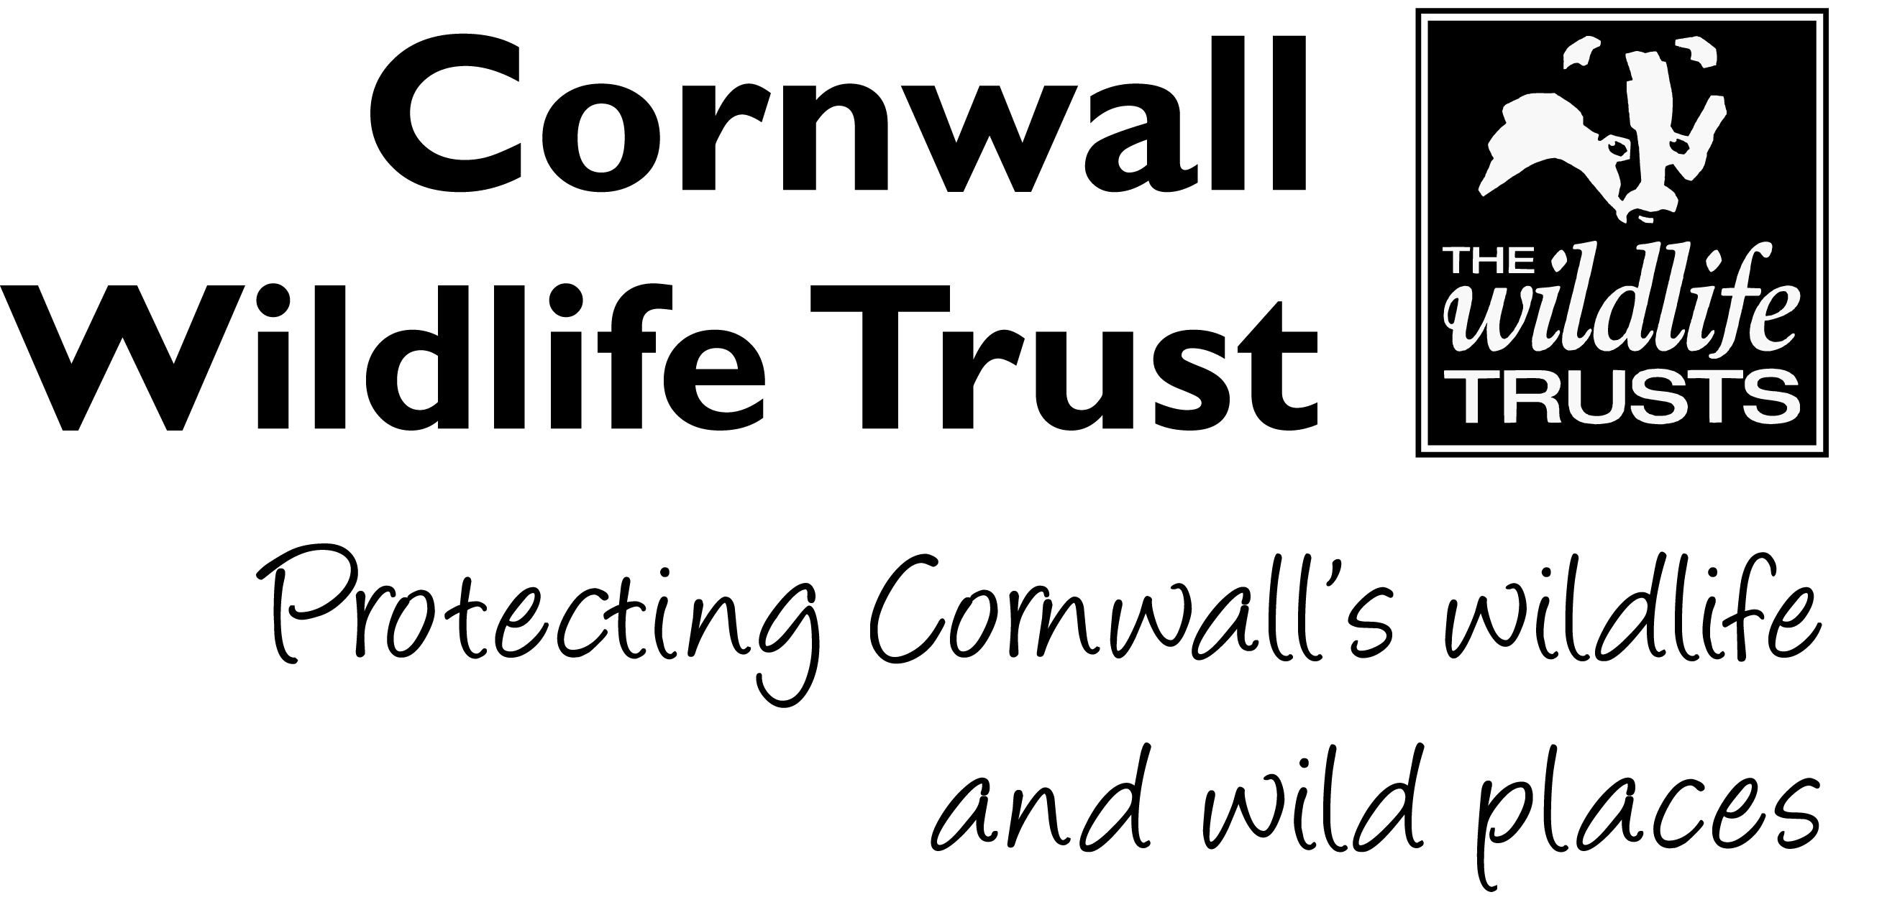

VOLUNTEER ROLE

1. Who

Volunteer Role: Distributor
Department: People and Engagement
Office: Allet, Truro
Support Officer: Community Fundraising Officer
Type of Role: Part time, Flexible

2. When

Application Deadline: 26th February 2020
Start date: 9th March 2020

3. Volunteer Role

The work of Cornwall Wildlife Trust covers the length and breadth of this beautiful county, and our calendar needs to as well! We are looking for volunteers who can help distribute our beautiful calendars and vital collection boxes; as its people’s donations that allow us to continue our work countywide. Working in your local community; be it village, town or parish, you can help Cornwall Wildlife Trust share its message with others.
It is useful for our Distributors to have a full, clean driving license and vehicle; in order to collect items from our headquarters in Allet and deliver in their local area (boxes of calendars can be quite heavy!) All travel expenses for this role will be covered.
This is a flexible role; allowing our volunteers to distribute items at a time that suits them. All that we ask is for collection boxes to be checked bi-annually and calendar stocks replenished when necessary.

4. Activities

- Distribute calendars/collection boxes to new and existing retailers.
- Retain contact with retailers and ensure sites are always stocked with our calendar
- OR that collection boxes are emptied regularly
- Update Community Fundraising Officer with relevant forms and locations of calendars/collection boxes
- Snap photos of wildlife that you see – every single piece of wildlife is important and ERCCIS (Environmental Records for Cornwall and Isles of Scilly) are always looking for helping hands to record the wildlife in our beautiful county!

5. The skills you need

- Full UK driving license and appropriately insured car
- Flexibility – available to complete role during shop opening hours
- Happy to speak to new people and businesses; promoting Cornwall Wildlife Trust and our Calendar/Collection Boxes – optional

It would be useful if you had….

- The ability to travel around your local area
- Long term interest in the volunteer role would be beneficial

6. Practical Considerations
This role requires you to have access to a vehicle that can be used for volunteering activities.

7. What’s in it for you?
You get to volunteer for a fantastic charity helping local wildlife, people and the environment. This will give you the opportunity to gain valuable experience working in ambassador role, engaging with staff and the general public. This is a chance to become part of a great team!

