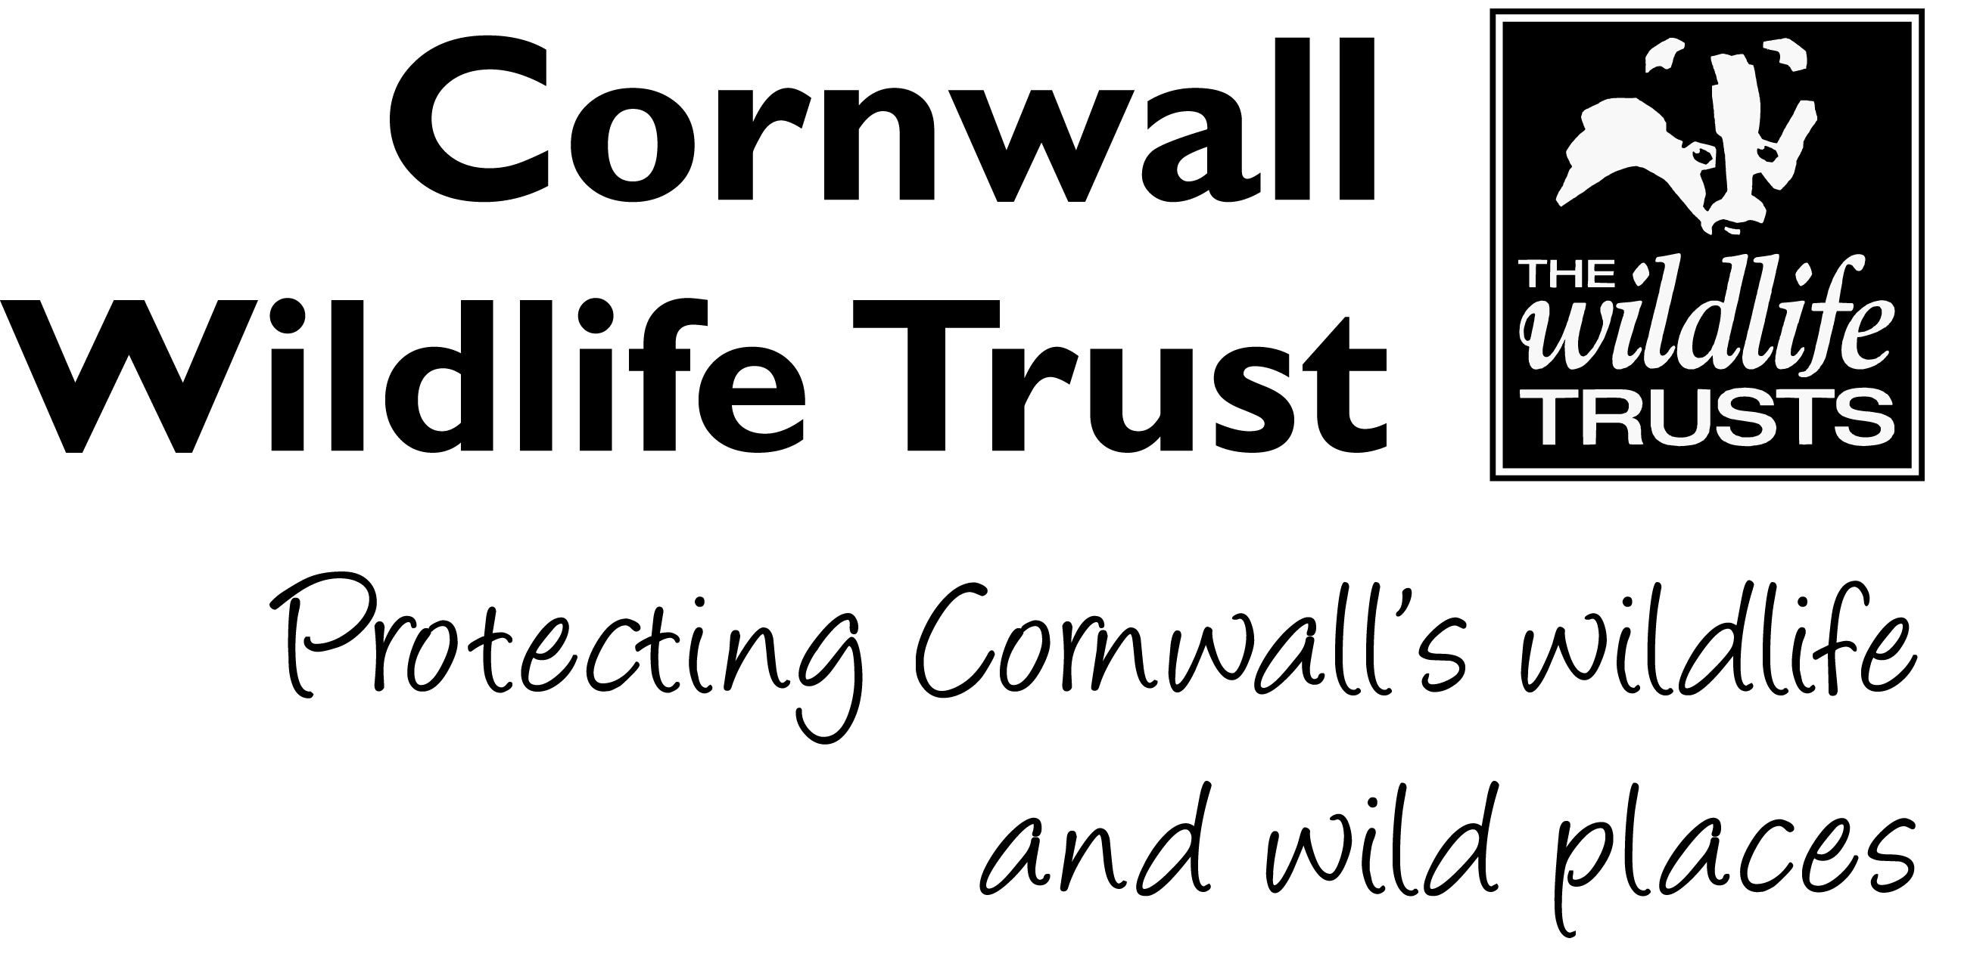

VOLUNTEER ROLE

1. Who

Volunteer Role: Ambassador
Department: People and Engagement
Office: Allet, Truro
Support Officer: Community Fundraising Officer
Type of Role: Part time, Flexible

2. When

Application Deadline: 20th January 2020
Interviews: TBC February 2020
Start date: TBC February 2020

3. Volunteer Role

Are you confident talking to new people? Do you love and support the work of Cornwall Wildlife Trust? Why not represent Cornwall’s leading local wildlife charity as one of our Ambassadors! Cornwall Wildlife Trust spans the length and breadth of this beautiful county, and we need people to deliver our message far and wide too.

We are looking for volunteers who are happy in public speaking situations, to talk at a range of events. This can include local communities and groups of all ages, businesses, fundraising events and more. We will supply you with training, information materials and any help you need.

As an ambassador, you will raise awareness and support for Cornwall Wildlife Trust and the work we carry out through your passionate and confident personality. Using your talents, you can help us show how important our beautiful Cornish landscapes are to wildlife and why we must protect them for generations to come.

This role will work on an ad-hoc basis, and so is best suited to someone with plenty of free time for promoting Cornwall Wildlife Trust! Any travel expenses will be covered inline with Cornwall Wildlife Trust’s volunteer expenses policy.

4. Activities

- General talks for local groups, communities and businesses
- Attending cheque presentations and face to face thank you events.
- Supporting, attending and participating in Cornwall Wildlife Trust fundraising events
- Distributing information and marketing materials in your local area and social media*
- Placing & Collecting Donation boxes in your local area*

*Optional additions to the role

5. The Skills You Need

- Good communication & presentation skills
- Confident and experienced at public speaking
- Good interpersonal skills
- Ability to work independently and as part of a team
- Well-developed IT skills with a working knowledge and understanding of MS Office packages such as PowerPoint
- Willingness to partake in activities, workshops and new opportunities
- The ability to act in accordance with CWT’s health and safety policy and procedures
- A love for Cornwall Wildlife Trust!

It would be useful if you had….

- The ability to travel around your local area
- Long term interest in the volunteer role would be beneficial

6. Practical Considerations
This role requires you to have access to a vehicle that can be used for volunteering activities.

7. What’s in it for you?
You get to volunteer for a fantastic charity helping local wildlife, people and the environment. This will give you the opportunity to gain valuable experience working in ambassador role, engaging with staff and the general public. This is a chance to become part of a great team!

